**INSE 6120: Cryptographic Protocols and Network Security**



**Professor: Ivan Pustogarov**

**Group member:**

|  |  |
| --- | --- |
| Student name | Student ID |
| SEYEDARASH SAEIDIMANESH | **40218948** |
| Maliheh Goliforoushani | **40206627** |
| Amirmohammad Souri | **40203060** |
| Seyedali Hasheminezhad | **40189424** |
| Hadi Mollaei | **40207126** |
| Nazanin Nasserifar | **40219010** |
| Armin Mansouri | **40231244** |
| Farzin Manian | **40196488** |
| Afshin Saberi Absardi | **40222638** |

**Abstraction:**

Docker is a containerization platform that allows for the creation and deployment of applications within lightweight, isolated environments. Docker allows us greater portability and flexibility, but it also introduces new security considerations. 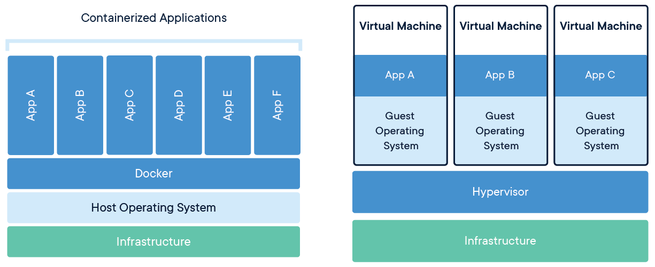

Virtualization and Dockerization are two techniques that we use to faster implement the infrastructure, however, these 2 methods are different. Virtualization involves creating a virtual machine that emulates an entire computer system, while Dockerization is creating lightweight containers that share the same operating system. Virtualization provides strong isolation but requires significant resource utilization, while Dockerization provides a more lightweight approach to deploying with less overhead. Docker containers can be deployed on any host that supports Docker, while virtual machines are typically deployed on dedicated hardware or cloud instances.

**Contents:**

**Introduction:**

To ensure security in Docker, various methods can be done at different levels, including securing the operating system, hardening the Docker daemon, and implementing the secure application.

In this project, we try to simulate attacks on docker using vulnerabilities on the docker daemon or OS to challenge docker weaknesses. In addition to that, we worked on different defense mechanisms for docker to address those weaknesses or increase security levels to protect docker daemon or containers.

**Attacks:**

**1. Shellshock [1]**SEYEDARASH SAEIDIMANESH & Amir Souri

**CVE-2014-6271**, also known as "Shellshock," is a critical vulnerability that was discovered in the Bash shell, a commonly used command-line interface in Unix-based operating systems. This vulnerability allows an attacker to execute arbitrary code on a vulnerable system by exploiting a flaw in how Bash handles environment variables. The impact of this vulnerability is significant because it can be exploited remotely over the network, and many systems that use Bash are exposed to the internet. Attackers can exploit Shellshock to gain unauthorized access to a system, steal sensitive information, or launch further attacks. The vulnerability was first disclosed in September 2014 and affected a wide range of systems, including servers, routers, and IoT devices. For all of the attacks I used Linux ubuntu-20.04.3-desktop-amd64 as a host on a virtual machine 16 and the last version for the docker

We can attack a docker in different ways one of them is running compromised dockers, that have vulnerabilities. This image **vulnerables/cve-2014-6271** is vulnerable to shellshock. This image exposes port 80 and if we map port 8080 this port can be exploited easily. There are some applications in this image that make the shellshock attack possible. so if we pull and run this image **cve-2014-6271** on the host machine and map the 8080 port on it as the below scripts. 172.17.0.1 is my host IP

The applications and vulnerabilities that can help with shellshock are available from the host IP and mapped port 8080

Script:



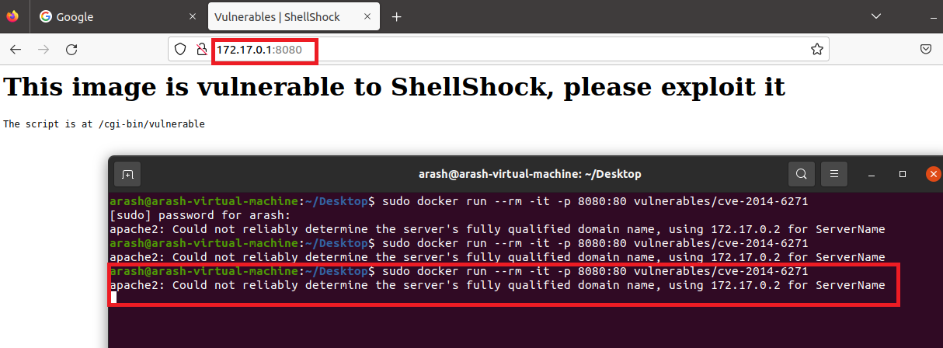

During this script running on the host if we run this bellow script we can access the etc password file

Script:



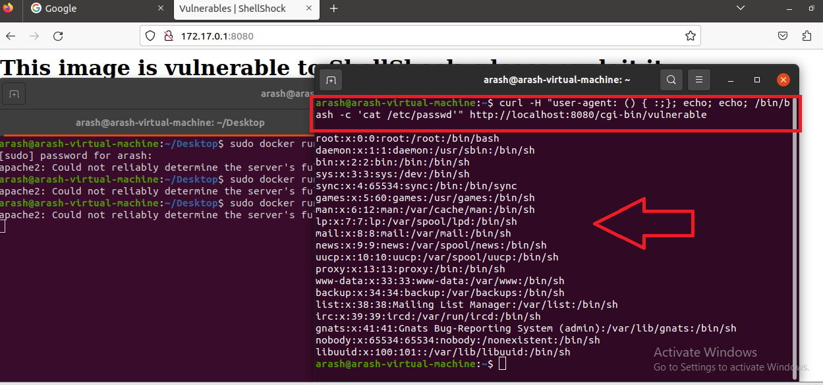

**1-2: shell shock exploit on web,**

In the beginning, I ran apache2 as a web server.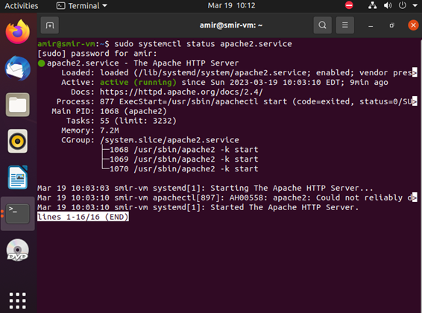

Then I ran the following command to run the docker container on port 8080: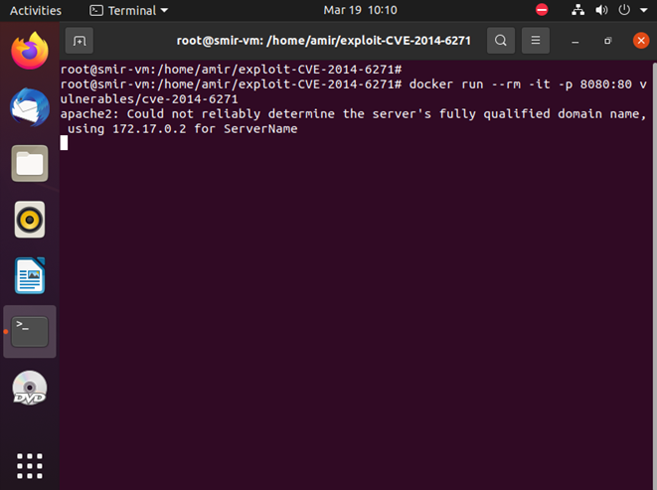

The attacker can access the web page of the docker container from its browser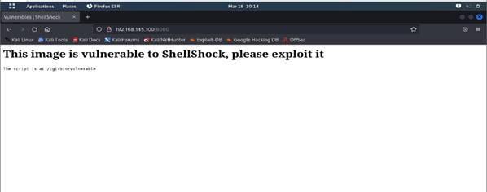

After that attacker run the exploit in the following:

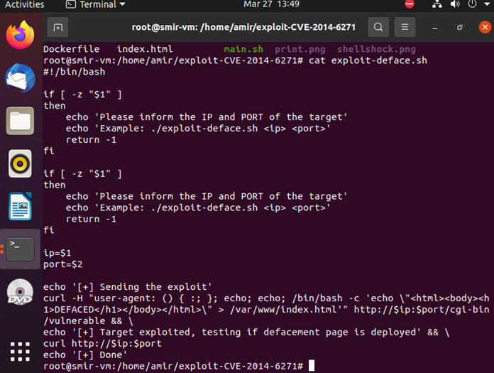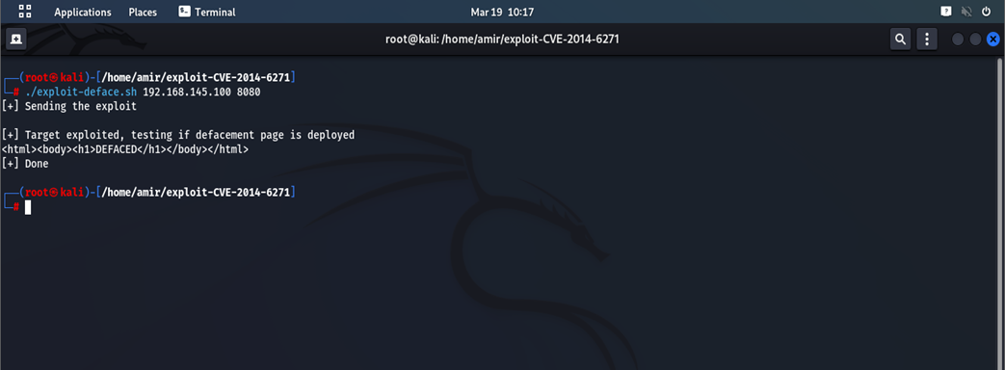

Using this vulnerability, the attacker will deface the web page.

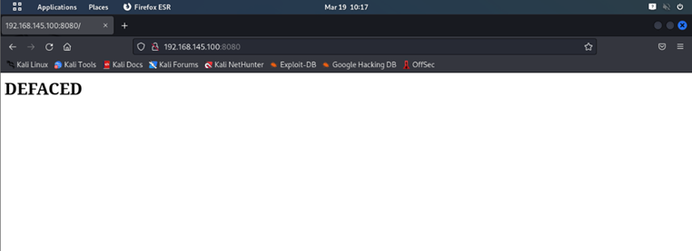

**2.REVERSE SHELL [1]**

SEYEDARASH SAEIDIMANESH

If we run the same image and map on the 8080 port as the previous exploit

Script:



and run a net cat listener on 4444 as bellow on one of our shell.



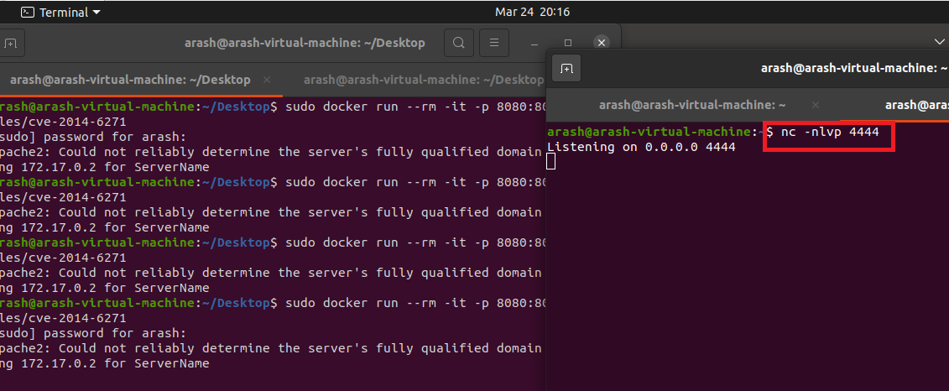

If we run this reveres shell script as bellow



at the same time, we can see on our listener shell as bellow

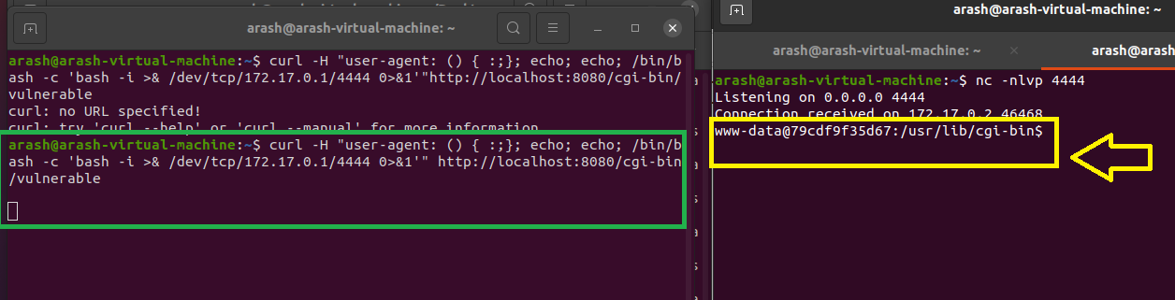

And we can see the attacker on the listener get a shell (yellow arrow)

**3.Container break-out technique [1]**

SEYEDARASH SAEIDIMANESH

The main idea for this attack is since we are in a container we have very limited access to the host so an attacker tries to escape from the container to have access to the host, If the container has the Docker.sock mounted on it we can escape from the container. When we run a docker a socket will be created on the docker client can interact with the docker by this socket For escaping from container to host we create a new docker with sock name and mount the /var/run/docker.sock file on our new container by below script 1

Script 1:



then we get a shell on our new container as bellow

script 2:



then when we get a shell we can check the file /var/run/docker.sock is mounted or not

then when we get a shell we can check the file /var/run/docker.sock is mounted or not

script 3:



then we install a docker client on our current running docker as script 4

then we install a docker client on our current running docker as script 4

script 4:

now we run a docker on our current docker that we have a shell on it that by this way we can have access to the underlying host, by the bellow script 5 we mount the host root directory on the test directory of our container as below, after running this script 5 we can have a shell on it also, and if we go to the /test directory we can see all the host root directory are mounted on this /test directory on our docker that we can access to the etc/passwd and etc/shadow file

script 5:



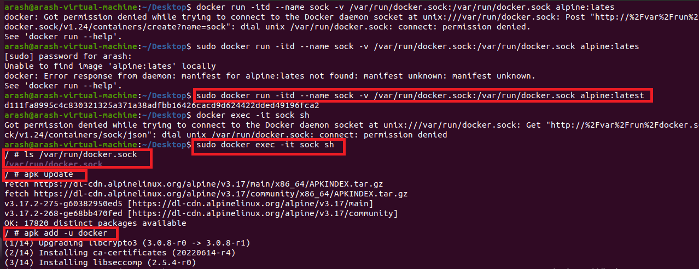

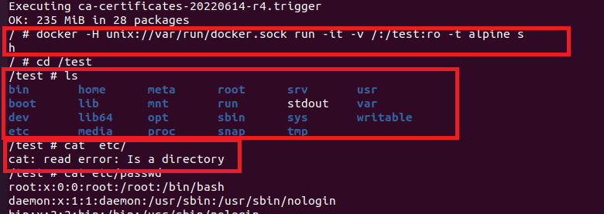

**4.Linux privilege escalation (root access on the host without password) [2]**

SEYEDARASH SAEIDIMANESH

For implementing this attack, we mount the root directory of the host on our docker and we can make any changes and manipulate these files through our docker, by bellow script we mount the root directory of the host machine on the /mnt directory of our docker that has alpine (alpine is a 5Mb Linux docker)

In the first step, we don’t have access to the root as bellow

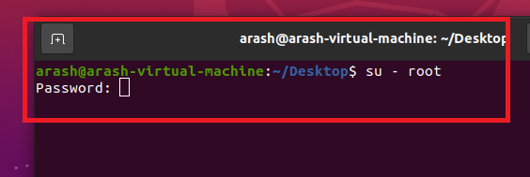

Script:



if we check the /mnt directory we can find all the host root directory on it as bellow and we can delete the root user password from etc/shadow file then we can switch to root on host without any password as bellow pictures

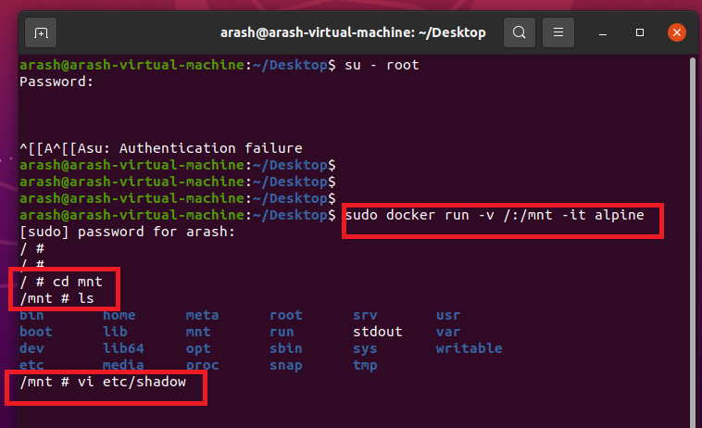

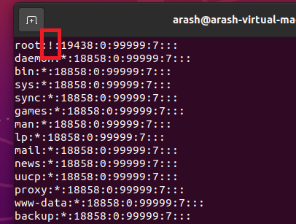

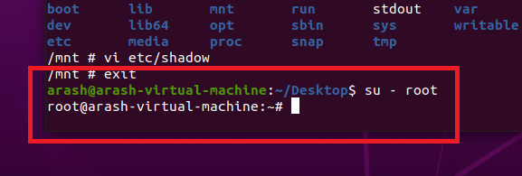

### 5- Dirty pipe

"Dirty pipe" is a vulnerability found in the Linux kernel which can manage the computer's hardware and software resources by all means. this particular vulnerability is a type of local privilege escalation vulnerability, which means that it can use to grant an attacker greater access to a system than they would normally have.

the name dirty pipe comes from another vulnerability used to known as "dirty cow." essentially dirty pipe allows the attacker to overwrite data in read-only files, so it will lead to injecting code into root processes obviously in the next step the attacker will gain root access to the system, which would give them virtually unlimited control over the computer or any system that uses that kernel.

The vulnerability was discovered by Max Kellerman in April 2021, although at the time he wasn't sure how it worked or how it could be exploited. However, since then researchers developed two different exploits based on Kellerman's original findings like the oncoming exploit. these exploits are available on the GitHub repository but they are generally complicated and require a deep understanding of how the Linux kernel works. the dirty cow vulnerability has also been detected in Docker containers. as we know containers share the same kernel as the host system, hence any vulnerability in the kernel can directly impact all the containers running on that system too.

Fortunately, this issue is fixed in the latest versions of the Linux kernel so the only thing is users keep their systems updated.

For the "dirty pipe" exploit, the Linux kernel version should be between 5.8 and 5.16. for this particular test, the Ubuntu version that I used was 20.04 and then I upgraded the kernel version to 5.10.5.

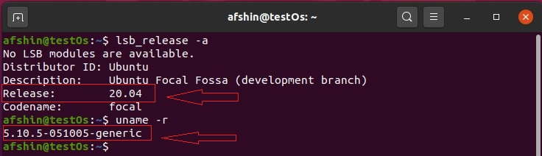

The user for this test was an unprivileged user called afshin

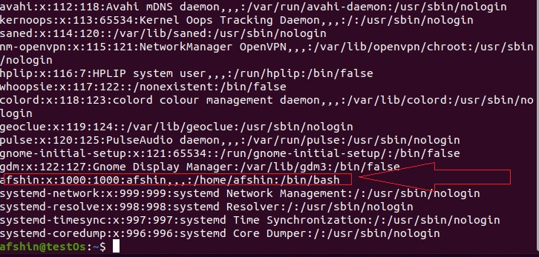

The user does not belong to the root group and as demonstrated it does not have any privileged to run basic sudo commands

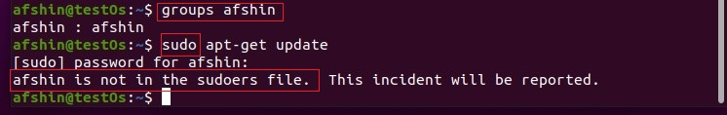

Then I checked the vulnerability of the kernel with the vulnerability scanner. to check if your Linux kernel is vulnerable to the "dirty pipe" exploit, I used the "dirty pipe checker", first navigate to the file location by cd command then ran the command "chmod +x dpipe.sh" to make the script executable after that run the command "./dpipe.sh" to run the script.

As it’s demonstrated in the figure my kernel was vulnerable but if you want to check another version simply you need to add the version that wanted to check after "./dpipe.sh" command.

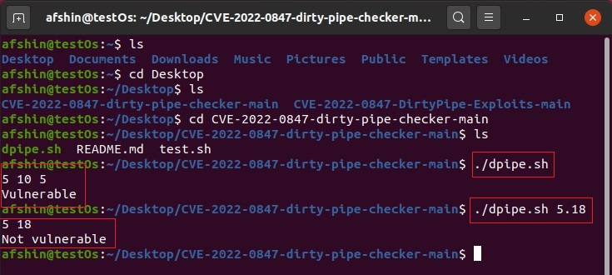

In the attack phase, we compiled exploit 1, a modified version of Max Kellermann's code. Its purpose is simply to change the root password in the /etc/password system file and then granting the user an elevated shell. The code is configured completely simple in syntax but deep in concept so it is remarkably user-friendly and can be customized to specific needs. As shown in the figure after executing that exploit file the root password was successfully changed to "INSE6120" with a backup of the original password saved in cash. The "whoami" command confirmed that the current user was "root." To demonstrate privileged access, an interactive shell with elevated privileges was opened with "/bin/bash -i" command, now the attacker can modify any data. After exiting the exploit, the root user reverted to the previous password, making it difficult to track the hack.

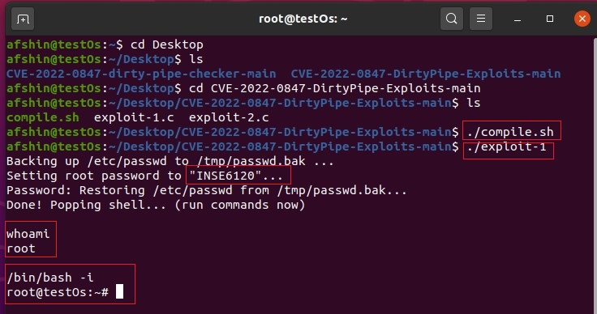

**6.Dirty Cow: ( CVE-2016-5195 ) [8]**

(Nazanin Nasserifar)

Copy-on-write, or CoW, is a method for copying data resources in an efficient manner. If a data unit is copied without modification, the "copy" can serve as a pointer to the original data. Only when the copied data is modified is a new copy created and new bytes written. When a process requests a copy of some data (e.g., a file), the kernel does not actually create the copy until it is written into.

Dirty COW (Dirty copy-on-write) is a vulnerability that has affected all versions of the Linux kernel since the release of version 2.6.22 in 2007. It is listed as CVE-2016-5195 in the Common Vulnerabilities and Exposures database. The flaw was identified in 2016 and completely patched in 2017. At the time of discovery, all Linux-based system users were vulnerable to the exploit.

**How does it work?**

The Dirty COW vulnerability enables processes to modify files that are designated as read-only. This exploit takes advantage of a race condition that exists within the kernel function responsible for the copy-on-write mechanism used by memory mappings. A race condition happens when multiple threads of a process attempt to change the same shared data simultaneously. An instance of this exploit can involve altering the user ID (UID) of a user in the /etc/passwd file to gain root access.

**Step1.** Definea new user unikl in our root

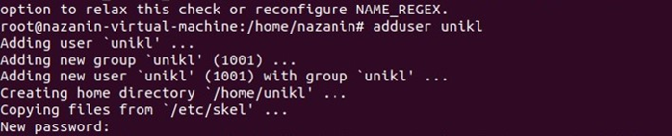

**Step2:** Check the id on unikl, which is 1001, and we want to run dirty cow on this uid.

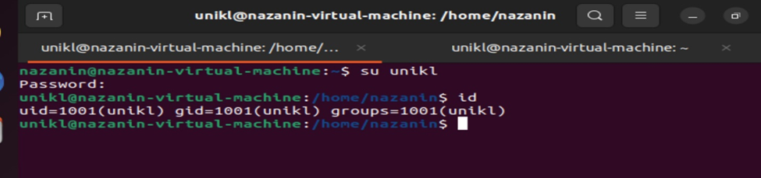

**Step3:** For unikl, there is no file on the dirtycow, so we must create a directory and generate dirtycow exploit file. [9]

script:



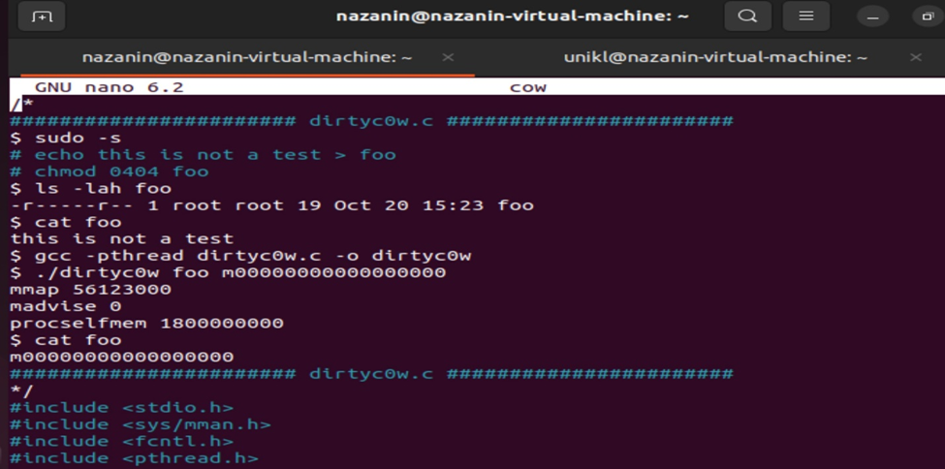

**Step4:** When we install the gcc (C compiler), we must compile while including the pthread library. We have placed the dirtycow in the unikl directory.

script:



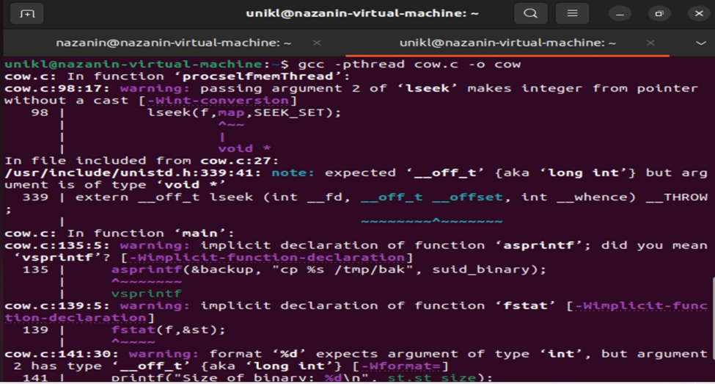

**Step5:** Run the exploit



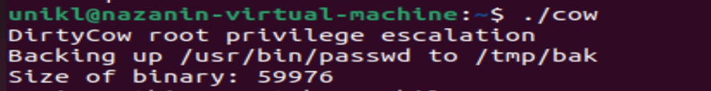

**Step6:** After gaining root access, the "id" command reveals that our UID is 0. Now, if we are the root user, we have control over the entire device.



Mitigation:

The most secure way to mitigate this vulnerability is to upgrade the kernel to a newer version that is no longer vulnerable.If we use an older kernel that is still vulnerable, we can update it with sudo apt-get dist-upgrade code and The system must then be rebooted using the command sudo reboot.

**7.CVE-2019-5736 [10] [11]**

(Armin Mansouri & Farzin Manian)

Runc serves as the core component of various systems, while tools such as Docker, Containerd, and CRI-O handle tasks related to data formatting and serialization on top of it. While Kubernetes itself is not typically vulnerable, it usually relies on those tools beneath it, including runc, which are potentially susceptible to security risks.

If a process inside a container is run as root (UID 0) and exploits a vulnerability in runc, it can gain root privileges on the host system. This would grant unrestricted access to the server and any other containers on it.

The primary source of risk is container images controlled by attackers, including unverified images from public repositories.

The vulnerable Docker version was installed on the VirtualBox v7.0. The operating system that is being used to implement the attack is Ubuntu ubuntu-19.04-desktop-amd64.

Ubuntu details:

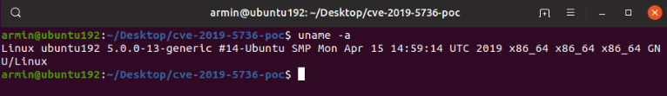



The Docker details:

sudo docker version



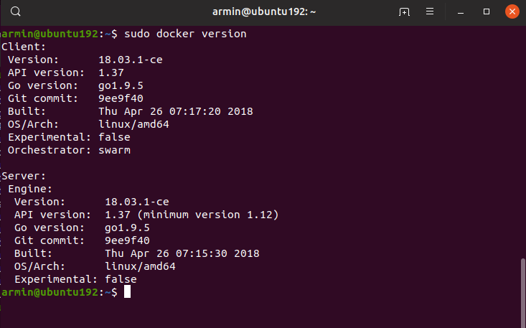

The exploit which utilized:



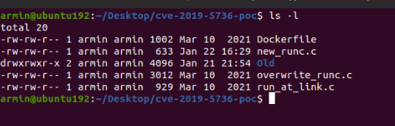

new_runc.c: In order for the attacker to be able to connect to the target, he/she should provide the IP address and the open port for the system to get connected back to. So the *new_runc.c* contains the IP address and port of the attacker.

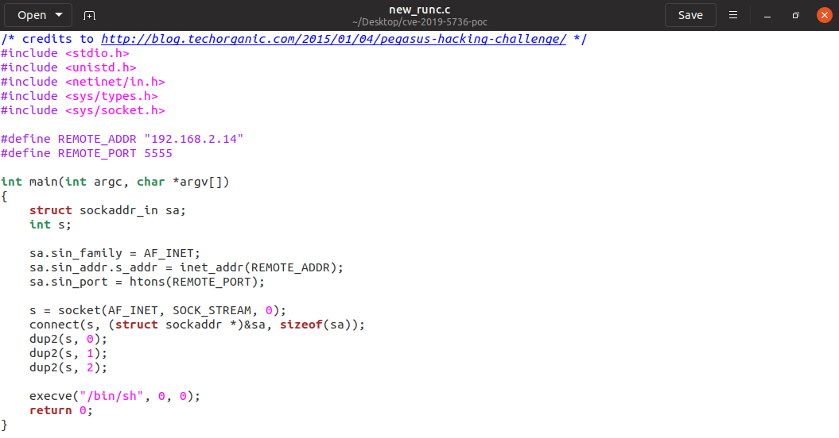

Now that the attacker has provided the IP address of the machine, next step is to setup a listener on his/her own machine, so that the vulnerable file can connect to. To set up the listener the *Netcat* software has been used:

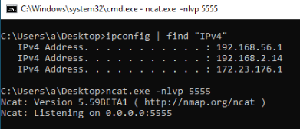



Building the container:

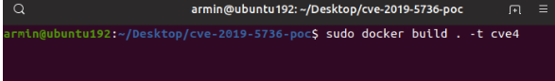



Successful build:

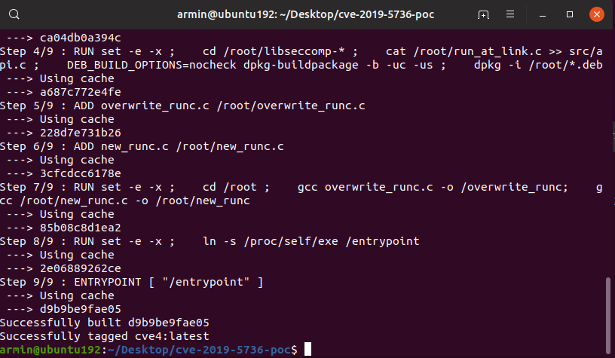

Executing the container:

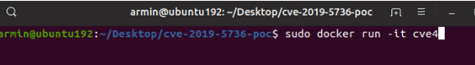



The victim will be connected to the attacker machine:

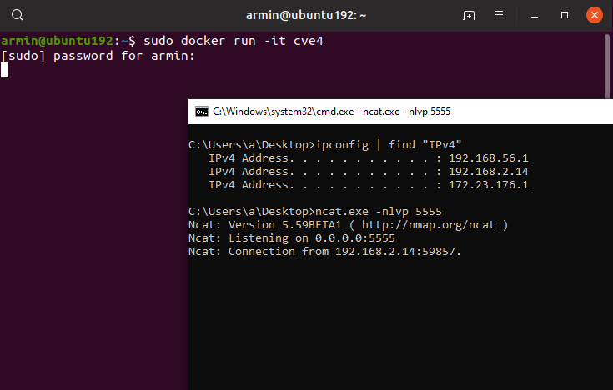

Then the attacker can execute the commands:

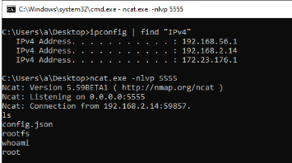

**Defense Docker**

there are different ways to protect containers against attackers, one of the most efficient them is to limit users and container accessibility on the host, by namespace and c Group we can set some limitations for the users.

**1.Namespace [3,4]**

SEYEDARASH SAEIDIMANESH

When a container runs on the host the container will have the accessibility of the host user that runs the container so if the user is in sudo group the container that is run by this user will be run as root on the host as bellow picture, and if the attack can escape or break out the container he can have root access on the host

**before**

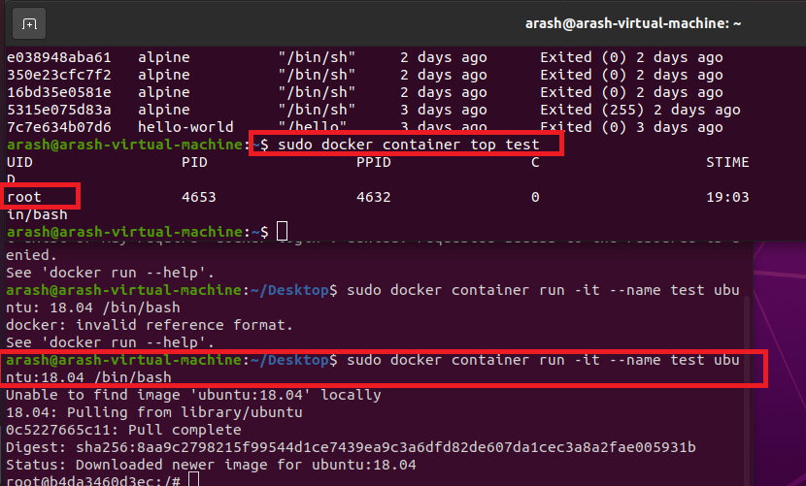

To solve this problem we use the namespace, first, we create a directory on this path on the host /etc/systemd/system and write the bellow script in this file override.conf to mandate the container instead of running with root user ID it is running now with docker remap user ID as the third picture in this section

In the other world by this script, we set the userns-remap="default" to the default

Script:





**After**

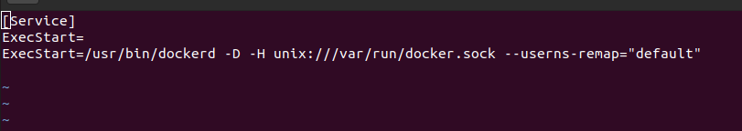

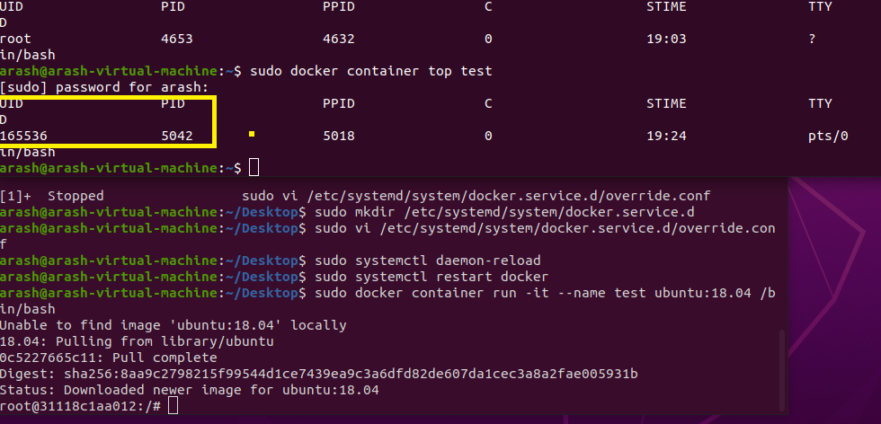

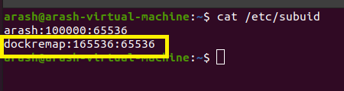

And also by adding this –icc=”false” in the upper script we can limit containers to communicate with each other

**2.C GROUP [1]**

SEYEDARASH SAEIDIMANESH

We can set the maximum number of processes that can be created on the container by the C group as below, here I set the maximum number of processes 7 so an attacker can not run more processes on the container. Based on the below picture there is a pids.max file in this path : sys/fs/cgroup/pids/docker/ that if we can check the maximum process number on our container that if we do not set any pids-limit when we run the container it would be max

**Script:**



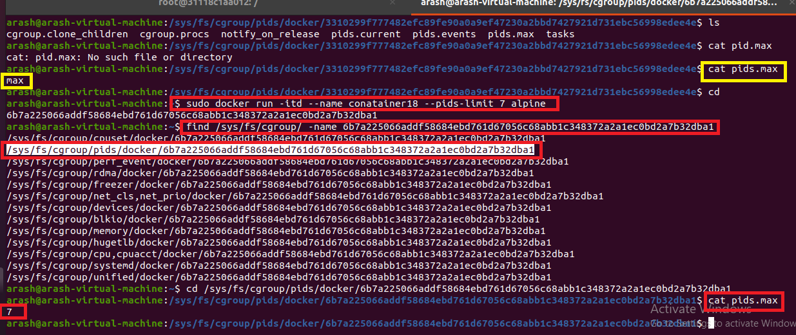

***3.*Docker-bench-security [5,6,7]**

Maliheh Goliforoushani

The Docker Bench for Security is a script that verifies dozens of common best practices for Docker container deployment in production. All of the evaluations are automated.

The following pre-built container is the easiest method to run your hosts against the Docker Bench for Security [5]:

script:



Finding and fixing vulnerabilities in the Docker host is easy with the assistance of the Docker Bench for Security script. In order to strengthen the host's defenses, acting on any alerts it issues are necessary. Although a high ranking is always desirable, Docker Bench is intended for real-world use. The local Docker installation of a developer may not need to pass all tests. After running the script, the warnings and deciding which ones are relevant to your setup must be pursued [6].

In Our project, we conducted the following steps to show how Docker Benchmark Security can verify vulnerabilities in a container and how to address them [7].

**Step 1**: First, we create a container and name it “Vulnerable 1”.

**Step 2**: We scan the docker with Docker Benchmark Security to assess the host.

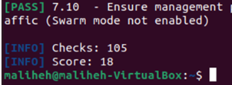

The number of Checks that were performed was **105**, which our score was **18**.

**Step 3**: There are a bunch of warnings created by this Docker Benchmark Security tool, we chose one of them to improve it.

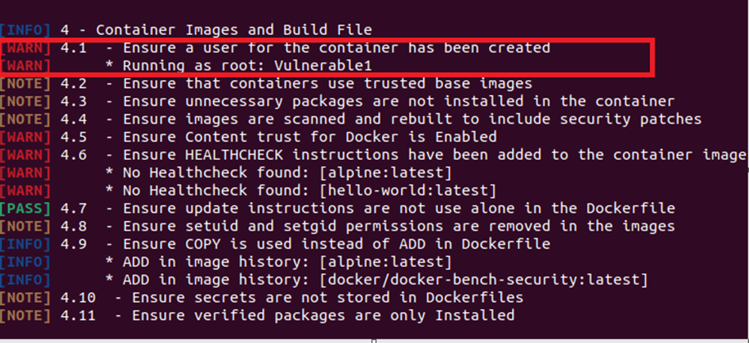

The warning: Ensure a user for the container has been created Running as root: Vulnerable1

This warning happened because the container “Vulnerable1” runs as root.

**Step 4:** we stopped this container and remove it from the file system:

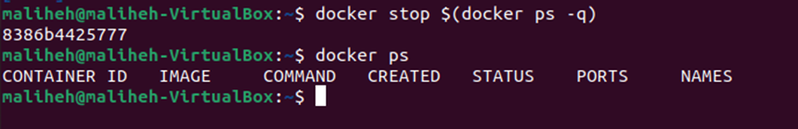

**Step 5:** in this step, we add new user to a container name “Vulnerable2” instead of starting with default options



**Step 6:** in this step, we get a shell from container “Vulnerable 2” and check to see the user is not root

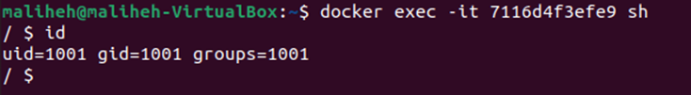

**Step 7:** we verify our privileges by typing: cat /etc/passwd

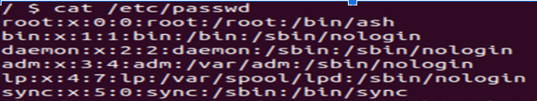

**Step 8:** to confirm that we do not have root privileges, we perform the following :

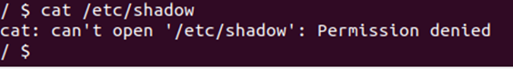

**Step9:** Finally, we perform the assessment to see if the tool will flag the issue of “user for the container is running as root user” again or not.

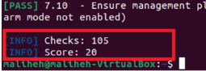

As we can see, by fixing the issue, the score has improved to **20**.



As a result, the warning regarding “the user for the container is running as a root” was addressed and we do not see it in the assessment anymore.

**4.Chef InSpec [3,5]**

SEYEDARASH SAEIDIMANESH

It is like *Docker-bench-security but the chef inspec input is more practical as bellow*

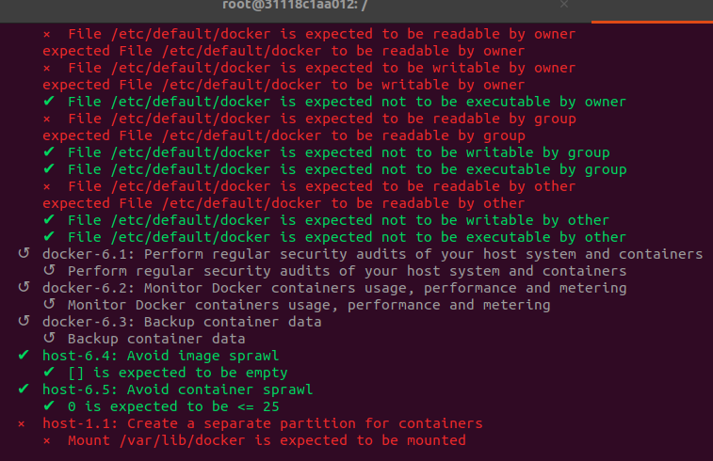

**5- Trivy Defense application**

(*Amir Souri)*

Trivy is an open-source vulnerability scanner that is designed to help identify security vulnerabilities in container images and their dependencies. Trivy uses a comprehensive vulnerability database and various vulnerability detection methods to identify potential security issues in container images. It can scan images hosted on a container registry, local images, and Dockerfiles. For using the Trivy defense mechanism I pulled a vulnerable container on my machine, Damn Vulnerable Web Application (DVMA), to check how Trivy can find the vulnerabilities.

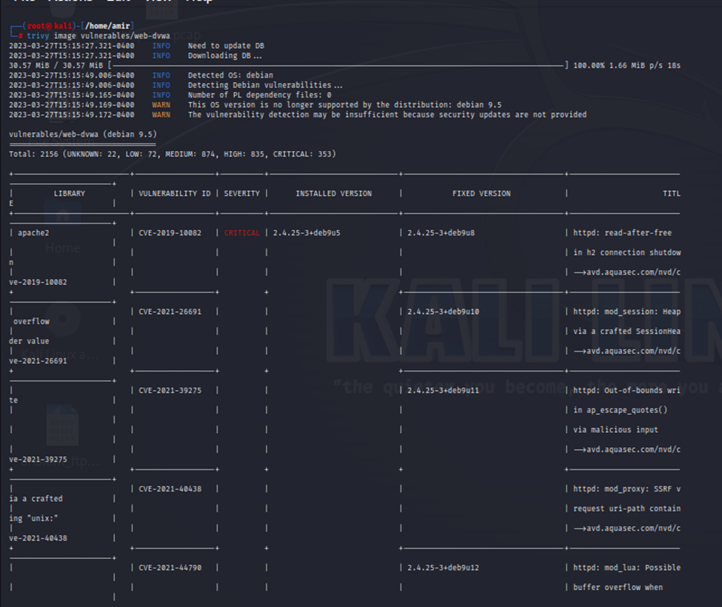

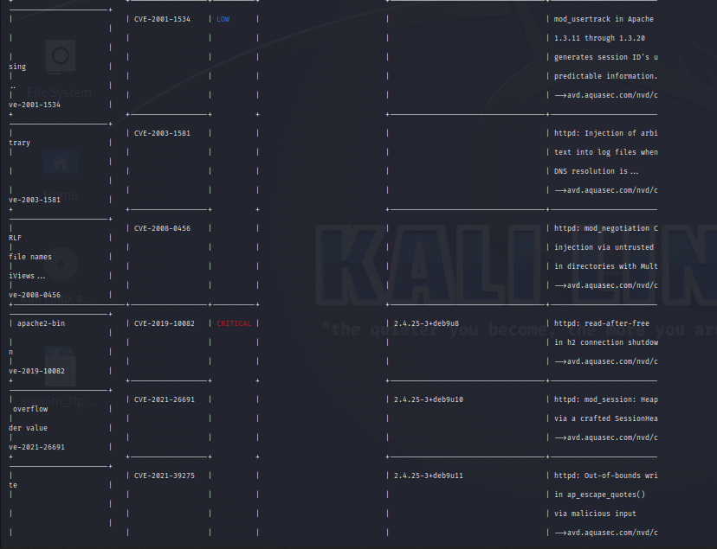

As you can see, since the container has multiple vulnerabilities, Trivy finds all of them, which can help security analysts to increase the security level in their organization for their docker containers.

**6.Capability:**

**(Ali-Hadi)**

In this section, I will discuss capabilities in detail. When it comes to the Linux operating system, root users are treated like royalty and granted privileged access. If I can divide these extraordinary talents into smaller parts, I will have more capabilities. Practically every ability normally associated with the root user has been decomposed into its component parts. I gain fine-grained control over what root users can do since these permissions may be broken down. That implies I can give the root user more authority, and I can also give the regular user greater authority on a case-by-case basis. By default, Docker drops all capabilities except those needed, and it uses a whitelist approach to do that. I can use Docker commands to add or remove it from the bonding set.

Script:

I can see that there are a few capabilities provided to the container by default. In current capabilities, it shows as cap_chown.

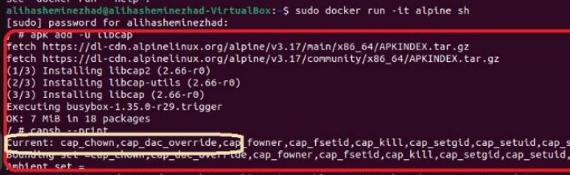

It is possible for the user who is using this container to remove some of these capabilities or add the capabilities that are not provided in this list by default.

Here, I create a simple file on the container using echo.

Script:



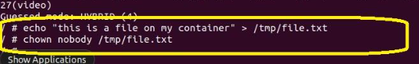

Now what I can do is spin up another container using Docker run.

Script:

What I am essentially doing is dropping the capability from this container.



This means I have successfully dropped this CHWON capability from this container. Now what I can do is quickly try creating a file on this container once again, this is a file on the container.

Before it, I can see in the picture below that I could drop the capability.

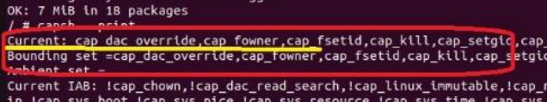

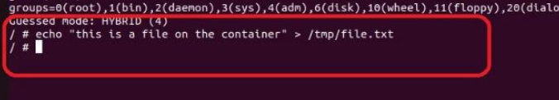

I am not allowed to run chwon command on this container even though I am the root but I can not able to change the ownership of this specific file because of the lack of chwon capability on this container for this account.

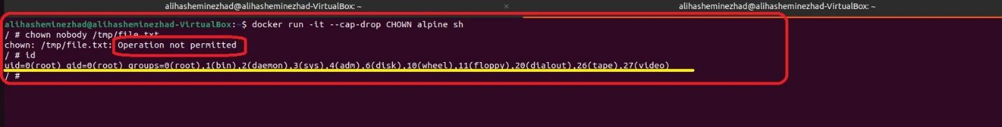

Assume that I want to drop all the capabilities from the container and add only one specific capability of our choice.

Script:

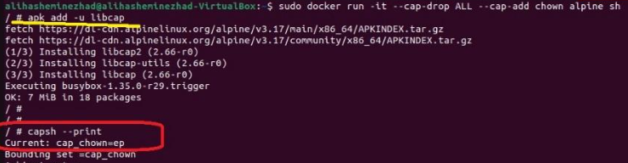

Only one capability is available this time, which is “capsh” this time, even though all the capabilities are dropped, we will still be able to perform this Chown operation in this container.

This is how we can make use of capabilities to have granular control over what privileges the root accounts have.

**7.Defence Method for CVE-2019-5736:**

(Armin Mansouri & Farzin Manian)

To address the security issue, we can either apply mitigation methods or upgrade your docker version to the one that includes the fix.

One of the defense options for CVE-2019-5736 in a Docker environment is to upgrade to a version of Docker that has been patched to include the fix for the vulnerability.



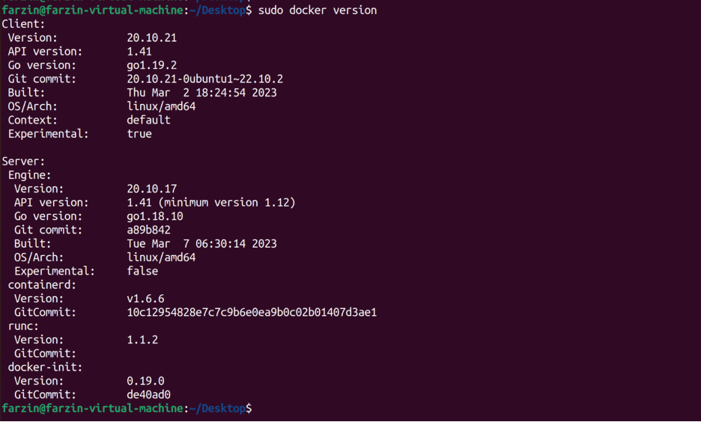

The other one is that to defend against an attack in a Docker environment is to restrict access to the Docker daemon. This can limit the impact of the attack and prevent unauthorized containers from running on the host system. To achieve this, access to the Docker daemon should only be granted to authorized users or groups.



Creating json file: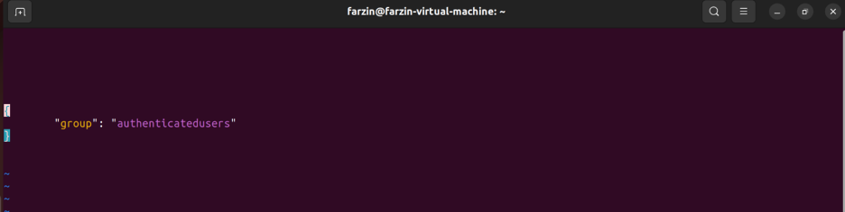

Before adding the user “farzin” to the group:

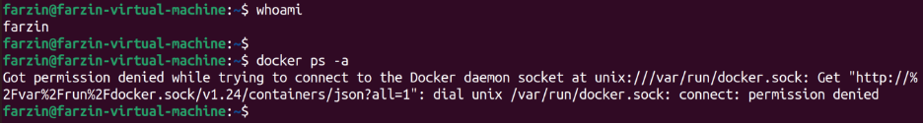

After adding the user “farzin” to the group:

**Reference**:

1. <https://www.youtube.com/watch?v=U0T1i4u_L1A>
2. <https://www.youtube.com/watch?v=pRBj2dm4CDU>
3. <https://www.youtube.com/watch?v=70QOBVwLyC0>
4. <https://www.youtube.com/watch?v=mQkVB6KMHCg&list=RDCMUC0ZTPkdxlAKf-V33tqXwi3Q&start_radio=1>
5. <https://github.com/docker/docker-bench-security>
6. https://www.t-systems.com/de/en/newsroom/expert-blogs/docker-bench-security-faqs-514384#:~:text=Docker%20 Bench%20for%20Security%20 is,3.1.
7. <https://www.youtube.com/watch?v=KOETuSKuPco>
8. RangeForce. “Dirty Cow.” RangeForce, <https://materials.rangeforce.com/tutorial/2019/11/07/Dirty-Cow/>.
9. <https://gist.github.com/rverton/e9d4ff65d703a9084e85fa9df083c679>
10. <https://nvd.nist.gov/vuln/detail/CVE-2019-5736>
11. <https://github.com/twistlock/RunC-CVE-2019-5736>
12. https://nvd.nist.gov/vuln/detail/CVE-2019-5736
13. <https://github.com/twistlock/RunC-CVE-2019-5736>